**LAB 6: Interacting and Observing Lottery Contract**

**Overview**

The purpose of this lab is to guide you on interacting with the lottery contract we just deployed on our Lab 5. This lab will also guide you on observing the deployed lottery contract on Etherscan.

**Prerequisites:**

You should have completed Lab 5 – Contract Deployment, received address of the lottery contract you deployed.

**Interacting with Lottery Contract Through Remix**

1. **Creating Multiple Account:**

Click the small fox icon on your chrome browser. Then Click on the Circle icon on top right of the popup box. Then you will see the option to create account.

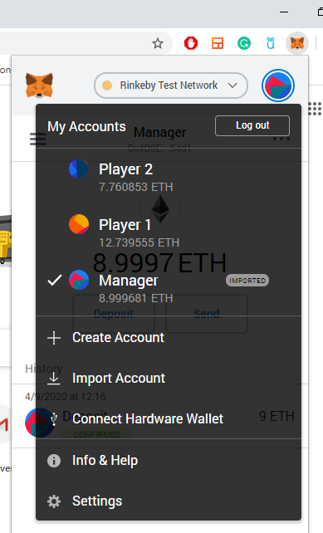

After you click Create Account icon, you will see screen like below:

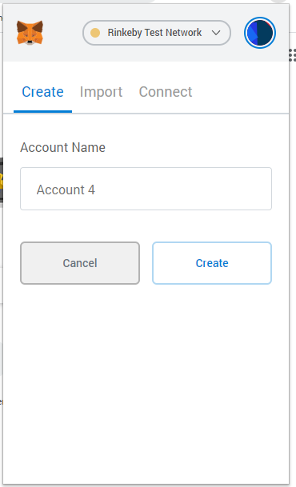

Type in the Name, you want to give your account. Then Click Create. I already created two more accounts having Name Player 1 and Player 2, and the account having name Manager is the one which I use to deploy lottery contract on our earlier lab. You can go to **faucet.rinkeby.io** to fund your created accounts. It will be the similar process as we did on our earlier lab.

1. **Importing Lottery Contract**

For someone to interact with your contract, they need to know two things:

* The address of the deployed contract.
* The contract’s Application Binary Interface (ABI).

You’ll get an address when you deploy your contract to a public network–either a test network or the main Ethereum network.

The ABI is what tells callers what functions are available, what arguments they take, and what they return. The ABI is generated for you by the Solidity compiler, and Remix exposes it from the “Compile” tab. Click “ABI” next to your contract Details section to copy the interface to your clipboard.

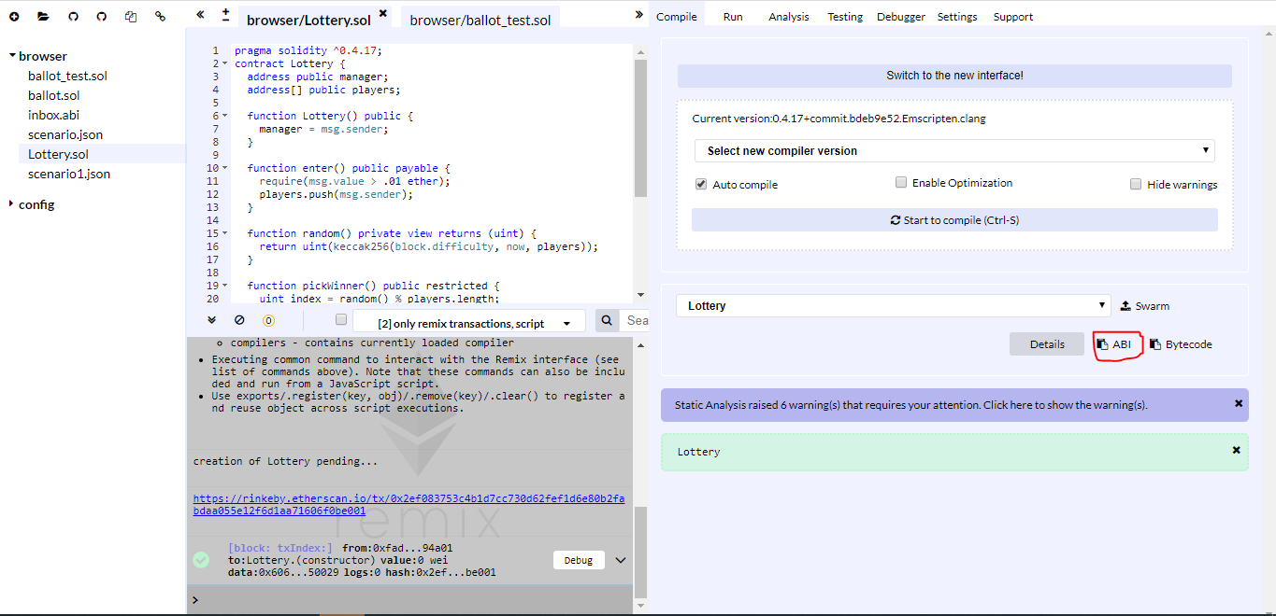

After you copy the ABI code, and paste it in Notepad, you will be able to see code something like below:

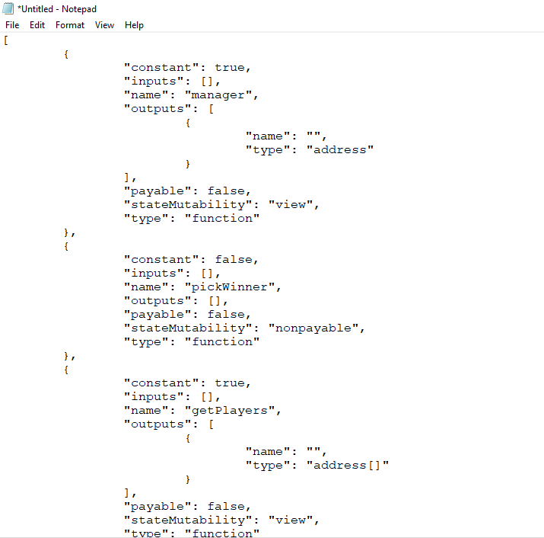

After you have the contract address and the ABI Code, then you need to perform the following things so that you can interact with your contract:

1. You have to go to Remix and create a new .abi file. And paste the ABI code you just have.

Click the “+” button on the top left screen.

1. After that, you need to go to “Run” Tab and on At Address then need to paste the contract address you just get from contract deployment. Click “At Address” button after you paste the contract address.

You will see warning that if you want to interact with the contract. Click “OK”

After that, you will see the contract on the right-hand side of the screen. Now you can interact with the lottery contract.

1. **Playing Lottery**

Let’s see the initial balance of the both players Player 1 and Player 2.

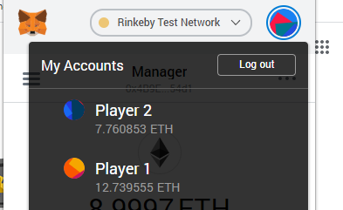

Now Select Player 1 on your Metamask and you will see the screen like below when selected:

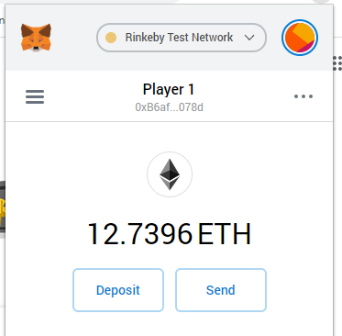

Go back to the Remix tab, where you just import lottery contract. See the following tab to verify you are using same player 1 account on Remix. The account address will match.

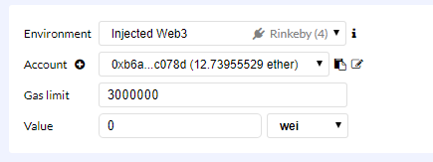

To enter into the lottery, change value to 1 and wei to ether. Click on enter Function call. 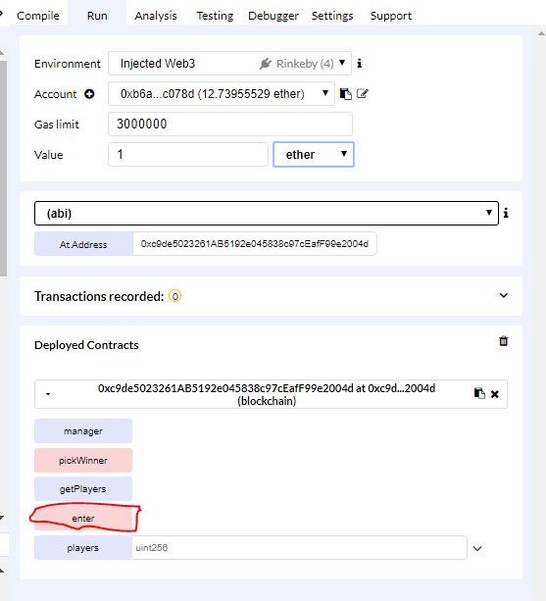

You will see a popup window to confirm your transaction.

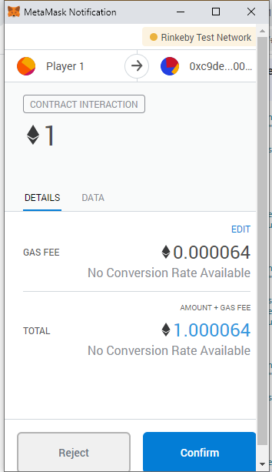

Click Confirm. Once you confirm you will see the change in balance of the player 1 account.

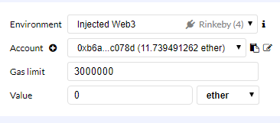

You need to do the same process with player 2. Once you complete the same process, you will notice the balance of player 1 and player 2 is changed by 1 ether and some gas fee:

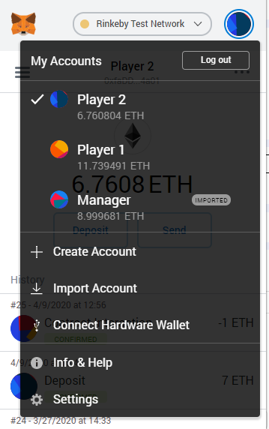

Now select the manager account, and click on getPlayers call, you will see the address of player 1 and player 2:

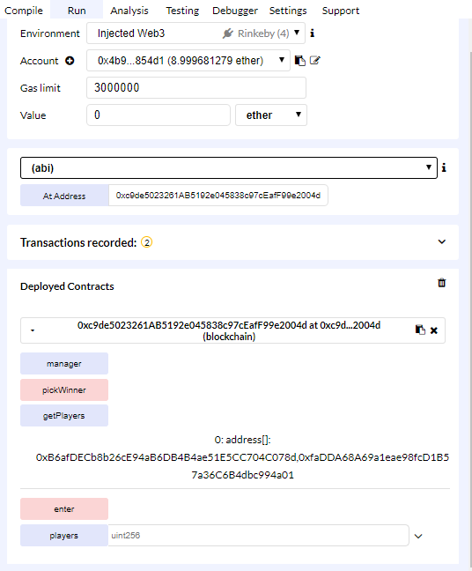

Other players can also perform these function calls, but remember only manager can call pickWinner function as per our lottery contract. Let’s click pickWinner and you will see the balance on one of the players is increased by 2 ether i.e. our prize pool was 2 ether.

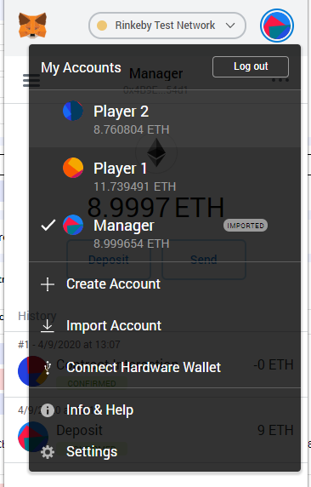

**Observing Deployed Lottery Contract on Etherscan**

Go to <https://rinkeby.etherscan.io/>

Paste the Contract address on the search tab and click search.

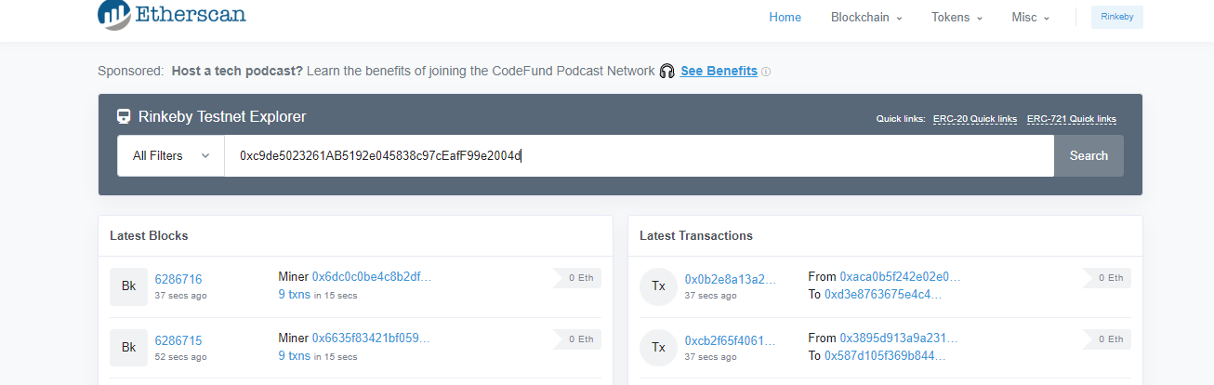

You will see the screen like below:

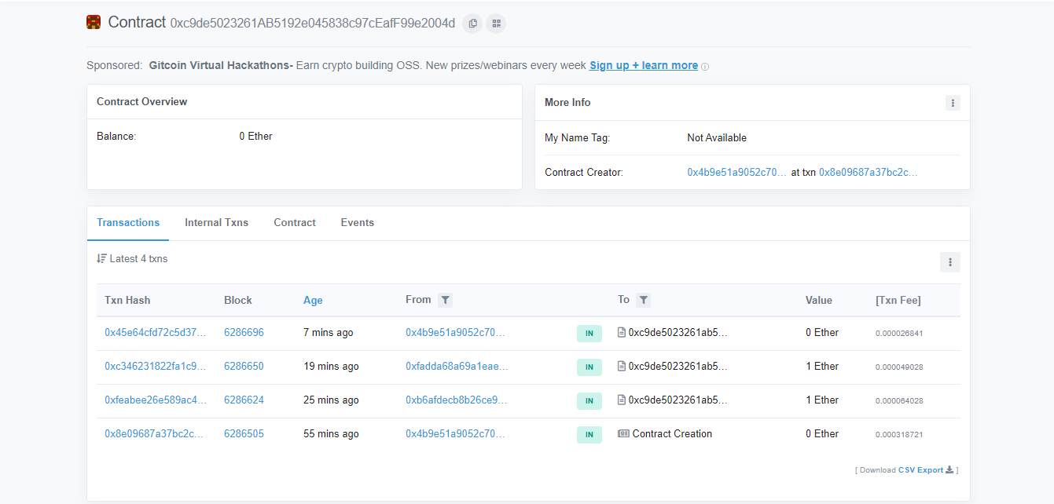

As you notice how the transactions are recorded when we are playing lottery on above session. You can see the manager of the contract as contract creator, and other players address too.